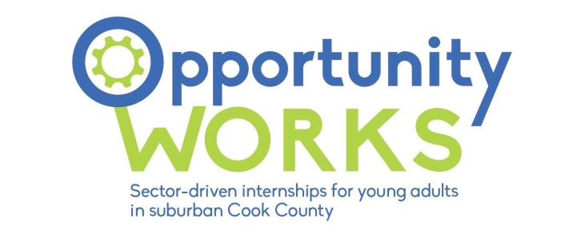
Partner Agency Program Report

*Complete this form and send to jwilliams2@chicookworks.org by 5pm on the 15th of April, July, October, and December during the program year.

Progress with Business Engagement:
1. Briefly describe your business engagement efforts and the interest level you are receiving from businesses to host Opportunity Works interns and/or participate in career exploration activities. For ongoing relationships – is interest sustained? What are you doing to cultivate business relationships that lead to more in-depth investment in interns’ success in the program?

2. Is there a story you would like to highlight related to business engagement and Opportunity Works? If yes, please share here.

3. Are Career Connect Business Services up to date? | Yes No
4. If no, please state date that Career Connect Business Services will be up to date.

Progress with Participants:
5. Is there a story you would like to highlight related young adult success in the Opportunity Works program? If yes, please share.

6. What, if any, challenges or difficulties have individual participants had which prevented success in Opportunity Works internships?

7. Are Career Connect Participant Services up to date? | Yes No
8. If no, please state date that Career Connect Services will be up to date. All metrics and outcomes noted in the participant detail report must be documented in Career Connect.

Program Planning:
9. Regarding Opportunity Works program implementation, what are your agency’s key priorities for the next quarter?

10. What activities do you have planned for upcoming ongoing weekly training days? Please list dates of training days and basic (one sentence/phrase) plan for the day. What career/hiring events do you have scheduled to host or attend? Please list dates of event days and basic (one sentence/phrase) plan for the day.

11. Have you sent calendar invites to jwilliams2@chicookworks.org for all career exploration and public events in the coming months? | Yes No
Additional Information:
Please use this space to share any other information you’d like share about program implementation.

