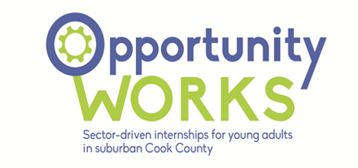

OPW 2023 Working Impact Survey Links

Career Coach-Mentor Survey
https://docs.google.com/forms/d/e/1FAIpQLSeoROqg6ff8X-x8l_CfREz76DeiFiyromvtI9esYvvMSaJdbg/viewform?usp=sf_link

Youth Survey
https://docs.google.com/forms/d/e/1FAIpQLSeWzdeoiZxFQ7IIPcKXB3qN9pLAa5hwH1wap_3dWohX7NHxRw/viewform?usp=sf_link

Employer Survey
https://docs.google.com/forms/d/e/1FAIpQLSf18VjSB3iYAlEIqPEDa0QSGl4_QdjZ5sld5tmLqI0DW9mvxw/viewform?usp=sf_link

