Agency Defined Programs: Pseudo SSN
Pseudo SSN Instructions
For the purpose of Agency Defined Programs, the Pseudo SSN feature has been enabled for customers that are awaiting Work Authorization. The Pseudo SSN feature enables Staff to create a customer profile and bypass initial Work Authorization criteria questions to participate in this NON-WIOA grant funding. See full steps below on how to create a Pseudo SSN for any New Arrival Customers below.

Assigning a Pseudo SSN to a New Arrival Customer

- Log into Career Connect and start creating a customer as usual.

- At the point of SSN Entry, select “I do not wish to provide my Social Security Number”
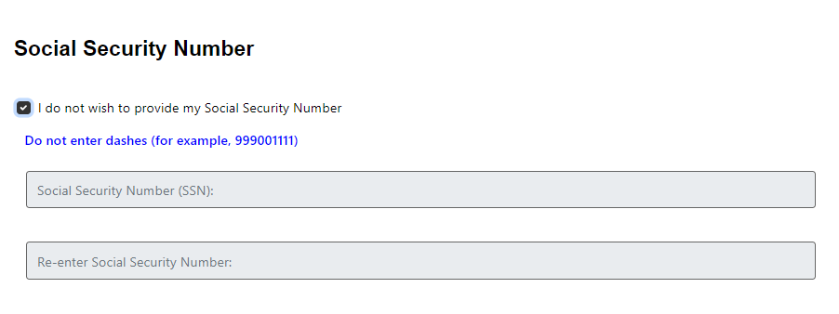
- When asked “Are you authorized to work in the United States?” select YES to bypass the Work Authorization criteria.
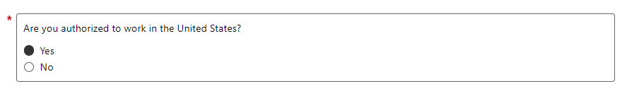

- For question “Have you registered with the Selective Service” select NO if customer identifies as Male. This should not hold up customer profile creation.
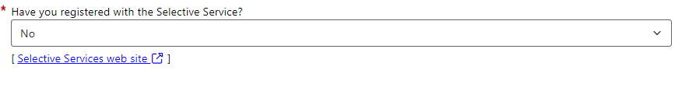
- At the point of selecting a Citizenship category, select “Alien/Refugee Lawfully Admitted to US”.
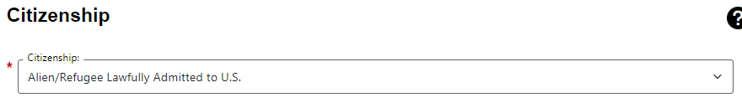

- When you select from the drop down, the system will give you the option to enter an USCIS Number. Do not fill in a number and continue the customer profile creation.
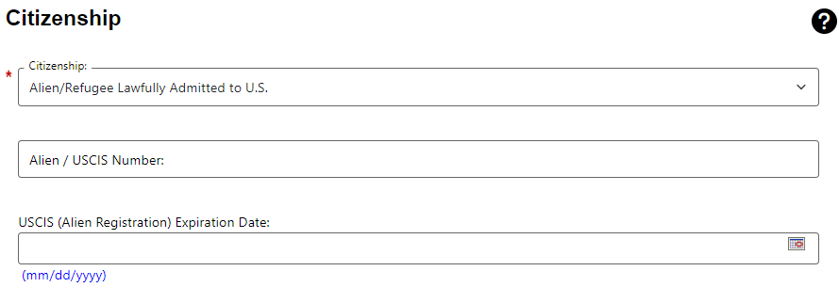

- Continue to the rest of the Customer Registration questions and answer them as they apply to your customer.

- After customer creation, immediately head to the customer’s case notes and use the WS24G Pseudo SSN Case Note Template by selecting the customer’s name under “What’s Next?”
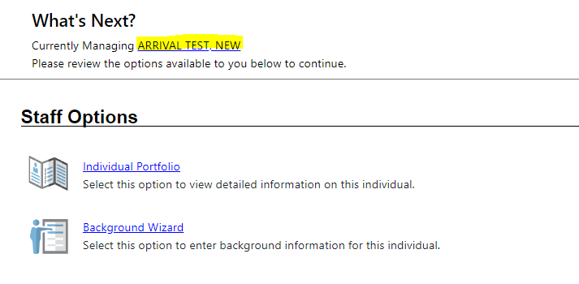

- Head to your customer’s case notes.
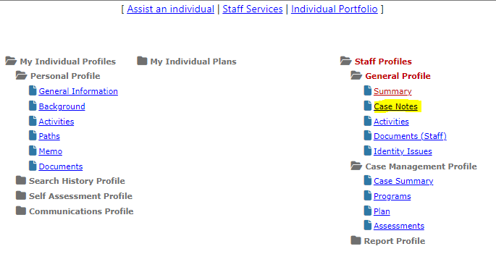
- Add a new case note using the “Non-WIOA Programs: Pseudo SSN” Template”. This template will fully complete the requirements of adding a Pseudo SSN for this program.
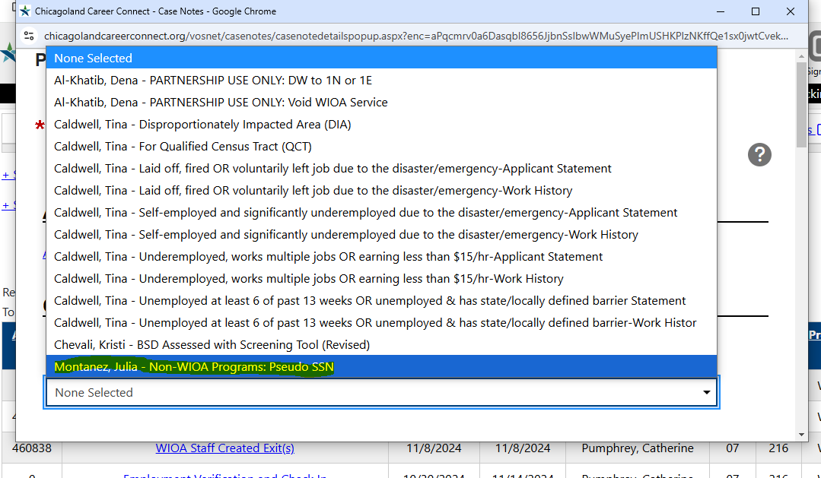

- The case note template will add required fields and a case note description that should not be edited.
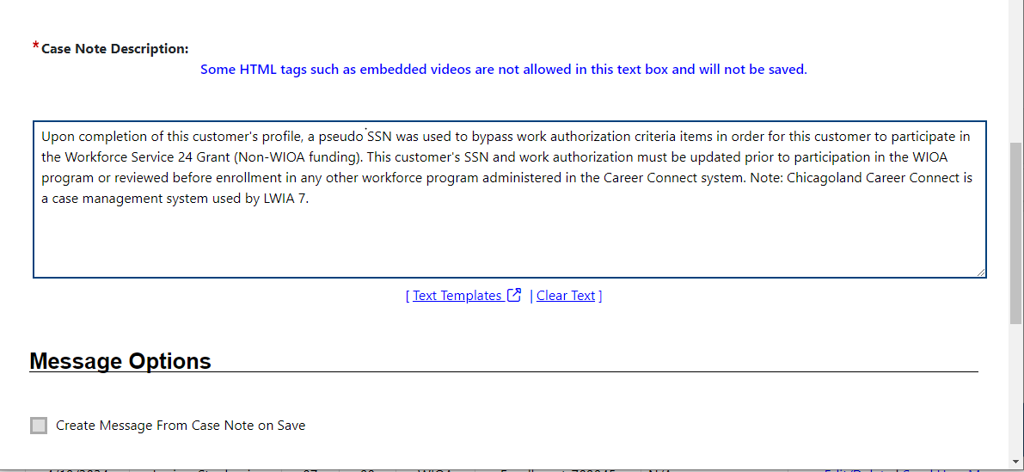

Congratulations! You have added a Pseudo SSN for your New Arrival customer.

Additional Notes
- This feature is enabled specifically for the purpose of Non-WIOA Programs. Though this feature is turned on, this feature cannot be used for all funding sources administered through the Career Connect System. Each step must be completed to assist other LWIAs to recognize the use of this special SSN identifier especially for WIOA funding.
- Any customer’s created with a Pseudo SSN/not authorized to work is not eligible to enroll in the WIOA Program.

Pseudo SSN Indicators in Career Connect
- General Information Tab > Staff Information Section
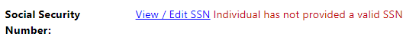
- General Information > Select “View/Edit SSN” > Review Pseudo SSN Checkbox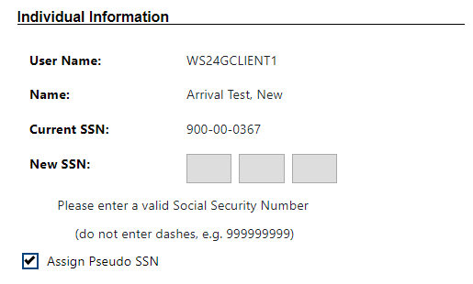
- Staff Profiles > Case Management Profile > “Individual has not provided a valid SSN” over each Case Management screen.
