
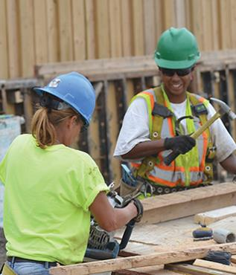
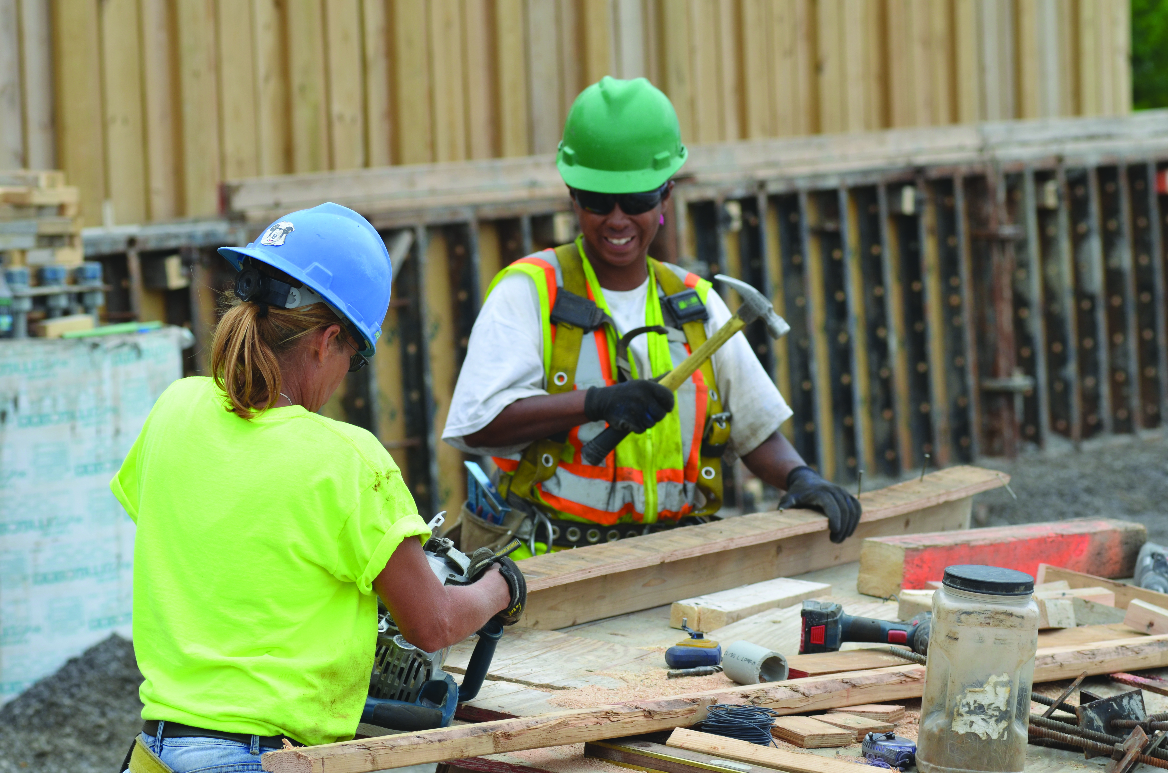
LEARN SKILLS TODAY THAT YOU CAN USE ON THE JOB TOMORROW
ConstructionWorks Powered by the Illinois Tollway is a FREE program designed to link job seekers with opportunities for rewarding careers in Illinois’ high-demand transportation related construction industry.
With a network of training partners throughout Northern Illinois, you’ll gain access to comprehensive job training, support, placement and retention services, so that you can work, thrive and secure long-term employment in the construction industry.
ConstructionWorks supports men and women seeking career opportunities and advanced participation within the skilled building trades including heavy highway construction. Services are available at designated locations throughout Chicago, Suburban Cook County, Waukegan, Aurora, and Rockford.
Customized Construction Industry Training
- Equipment Operators • Electricians • Cement Masons
- Carpenters • Iron workers • Laborers

LEARN SKILLS TODAY THAT YOU CAN USE ON THE JOB TOMORROW
ConstructionWorks Powered by the Illinois Tollway is a FREE program designed to link job seekers with opportunities for rewarding careers in Illinois’ high-demand transportation related construction industry.
With a network of training partners throughout Northern Illinois, you’ll gain access to comprehensive job training, support, placement and retention services, so that you can work, thrive and secure long-term employment in the construction industry.
ConstructionWorks supports men and women seeking career opportunities and advanced participation within the skilled building trades including heavy highway construction. Services are available at designated locations throughout Chicago, Suburban Cook County, Waukegan, Aurora, and Rockford.
Customized Construction Industry Training
- Equipment Operators • Electricians • Cement Masons
- Carpenters • Iron workers • Laborers
Free Services for Job Seekers
Career Coaches Can Help You

- Assess abilities and interests
- Develop career plans
- Learn skills to be successful
- Find jobs and apprenticeships in
the building trades
- Access other employment opportunities
and training referrals
- Ongoing retention support
Access to Support Services Designed to Help You Be Successful
- Transportation • Drug counseling
- Childcare • Basic skills and adult education referrals
- Financial coaching • Other fees
Am I Eligible?
Individual participants must be:
- 18 years of age or older
- Eligible to work in the United States

- Unemployed, underemployed or seeking career growth in the construction industry.

About the illinois tollway and constructionworks
The Illinois Tollway is a driving force for increasing economic opportunities in the diverse communities it serves. ConstructionWorks Powered by the Illinois Tollway is an innovative program designed to create a qualified pipeline of diverse men and women ready to enter careers in the heavy highway and related construction industry.

Illinoistollway.com
Free Services for Job Seekers
Career Coaches Can Help You
- Assess abilities and interests
- Develop career plans
- Learn skills to be successful
- Find jobs and apprenticeships in
the building trades
- Access other employment opportunities
and training referrals
- Ongoing retention support
Access to Support Services Designed to Help You Be Successful
- Transportation • Drug counseling
- Childcare • Basic skills and adult education referrals
- Financial coaching • Other fees
Am I Eligible?
Individual participants must be:
- 18 years of age or older
- Eligible to work in the United States
- Unemployed, underemployed or seeking career growth in the construction industry.
About the illinois tollway and constructionworks
The Illinois Tollway is a driving force for increasing economic opportunities in the diverse communities it serves. ConstructionWorks Powered by the Illinois Tollway is an innovative program designed to create a qualified pipeline of diverse men and women ready to enter careers in the heavy highway and related construction industry.

Illinoistollway.com

