LEARN SKILLS TODAY THAT YOU CAN USE ON THE JOB TOMORROW

ConstructionWorks Powered by the Illinois Tollway is a FREE program designed to link job seekers with opportunities for rewarding careers in Illinois’ high-demand transportation related construction industry.

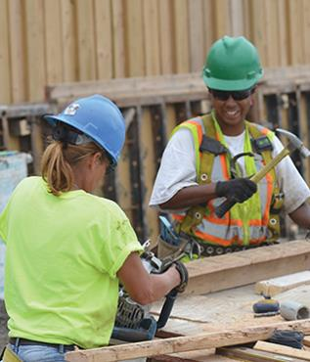With a network of training partners throughout Northern Illinois, you’ll gain access to comprehensive job training, support, placement and retention services, so that you can work, thrive and secure long-term employment in the construction industry.

ConstructionWorks supports men and women seeking career opportunities and advanced participation within the skilled building trades including heavy highway construction. Services are available at designated locations throughout Chicago, Suburban Cook County, Waukegan, Aurora, Joliet, and Rockford.

Customized Construction Industry Training

* Equipment Operators • Electricians • Cement Masons
* Carpenters • Iron workers • Laborers

**Free Services for Job Seekers**

**Career Coaches Can Help You**

* Assess abilities and interests
* Develop career plans
* Learn skills to be successful
* Receive ongoing support
* Find jobs and apprenticeships in   
  the building trades
* Access other employment opportunities   
  and training referrals

**Am I Eligible?**

Individual participants must be:

* 18 years of age or older
* Eligible to work in the United States
* Unemployed, underemployed or seeking career growth in the construction industry.

For more information contact: