ITA Request Submission Guide - IWDS 2.0
Purpose: This guide explains how to create and submit an Individual Training Account (ITA) request in IWDS 2.0 using the Occupational Skills Training service.
New! ITA Updates:

Before you begin, the customer must have completed the following prerequisites below:
- Customer Intake, Prescreening, and Getting Starting Assessments (GSA).
- Complete required eligibility, required documents uploaded, and completed application.
- Customers will be assigned a Career Planner.
- Universal Plan activities have been added, which include Goals, Steps, and Services related to ITA, completed with the customer, and the Universal Plan is signed by the career planner and customer.

General Requirements:
Before requesting an ITA:
- Complete the Training & Education Assessment (TEA)
  - Migrated Customers: Manually add the TEA
  - Upload the 2 TARA Forms to IWDS 2.0

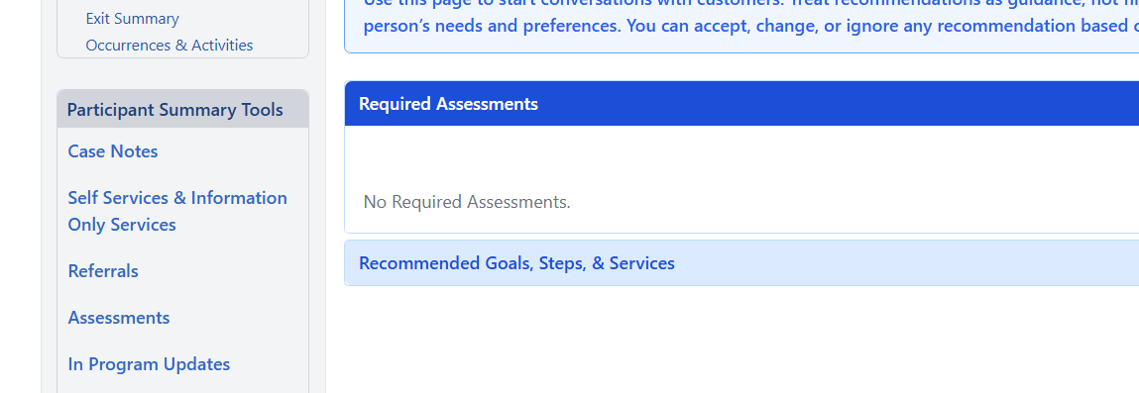
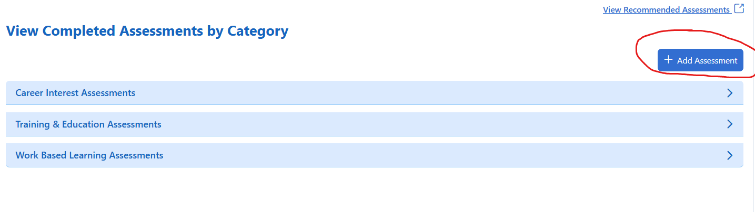
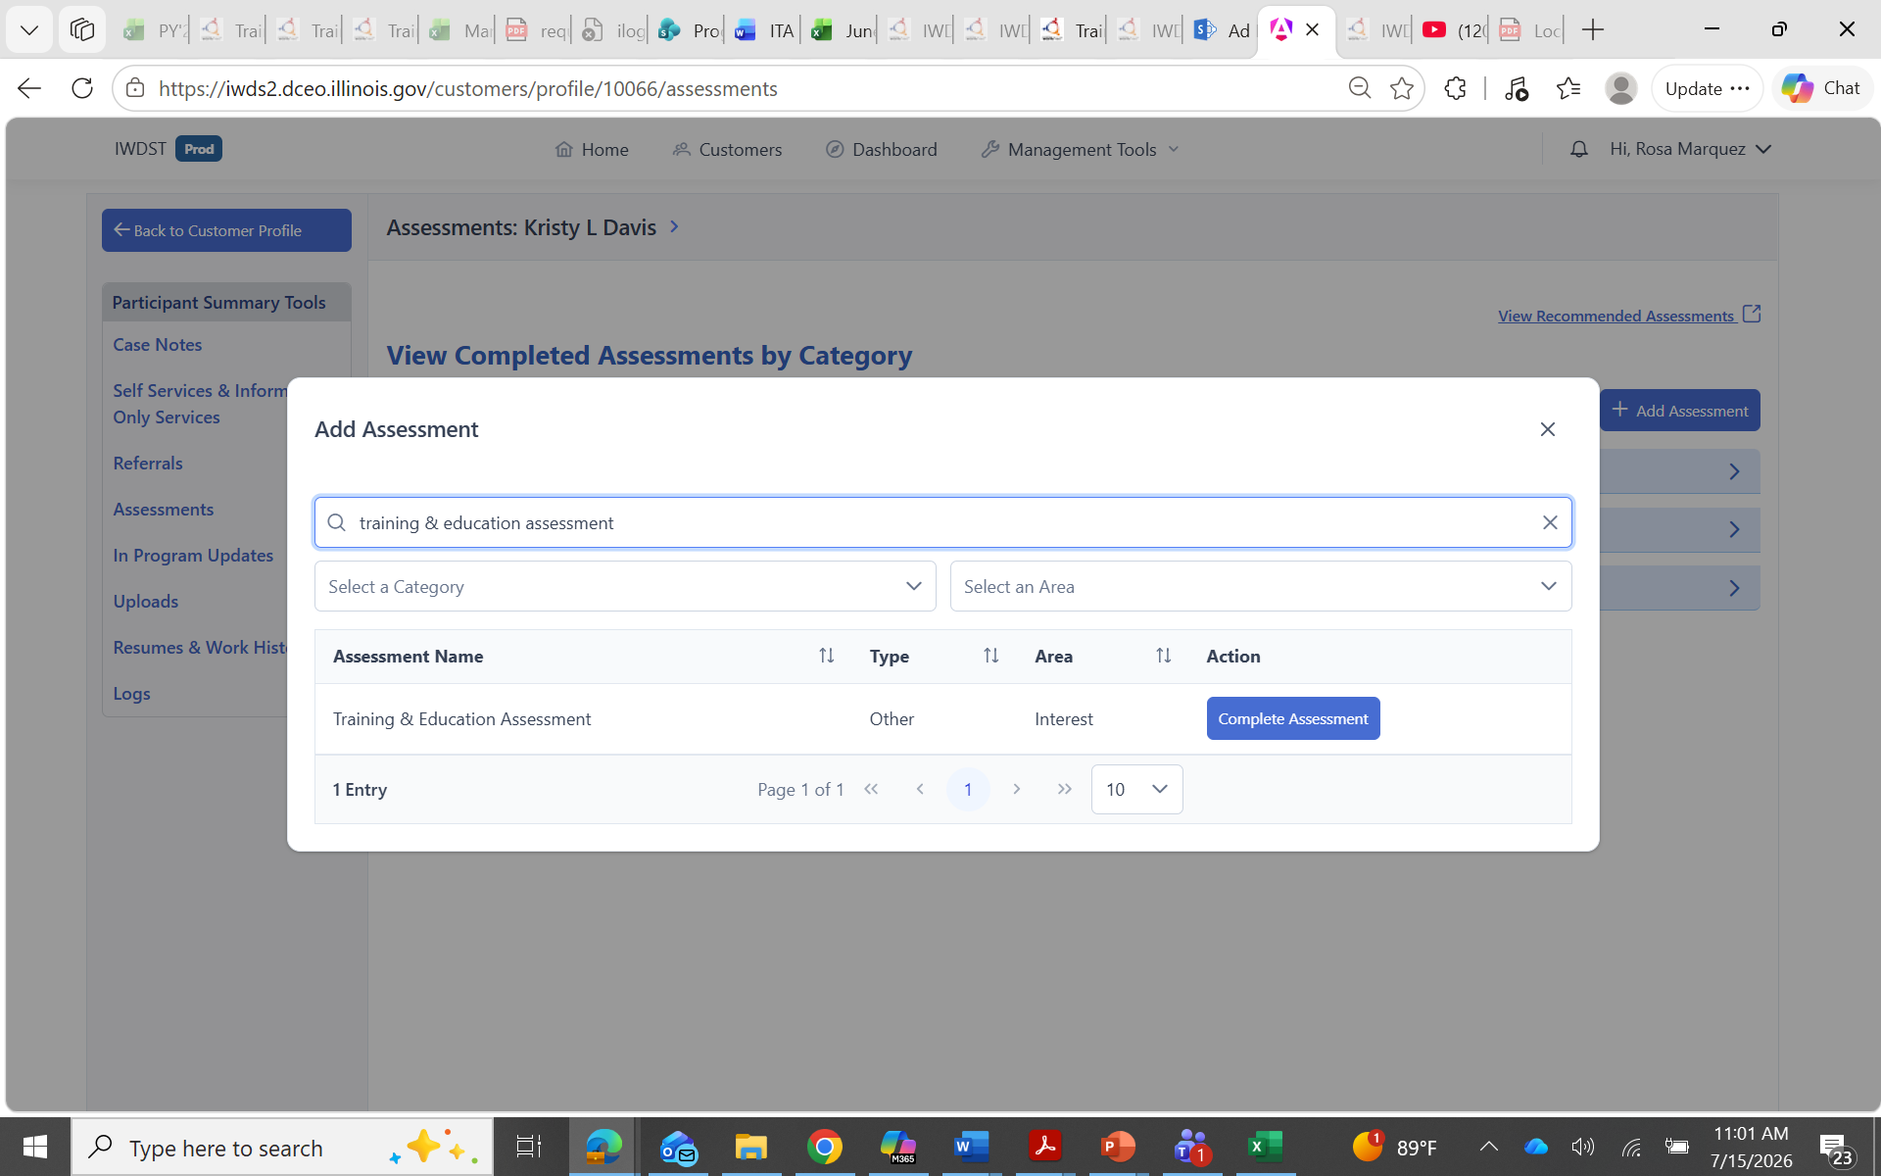

All Customers

- Customers can view and select training options through:
  - Illinois workNet or
  - The Training Options section within the Training & Education Assessment (TEA) in IWDS 2.0.
- NEW! The customer must submit one completed Training Exploration Form (TARA) from their chosen training provider and upload it to IWDS 2.0.
- The career planner must enter the customer’s CASA Goals Assessment for Reading and Math unless they meet one of the exemptions defined in WIOA Policy.

Timing. Do not begin with the ITA request unless training is imminent — generally within the next two weeks.

Case Note Requirements
- Training Exploration Form Results: Document the 2 or more schools that the customer compared, including school name, contact person, and which school was chosen and why.
- Training Justification: Document that the customer is suitable for the chosen occupation based on the Training & Education Assessment (TEA) For example: current skills, skills needed for the program, job readiness/career exploration testing, and relevant assessment results.
- Yellow Occupations (if applicable): If the chosen program is classified as Yellow, document that the customer was informed the occupation is in lower demand or lower wage than green occupations, that the career pathway was explained, and that the customer understands and wants to proceed.

Step-by-Step Procedure

Step 1 — Complete the prerequisites
Confirm that every item in the Prerequisites section above is complete and documented before continuing.

Step 2- Create a Goal & Step for Training (Select only the appropriate one

- The following goals are the ONLY Goals on the Career Plan, which will allow you to open the Occupational Skills Training Service. So you will want to select the appropriate goal for your customer.

- Finish a training program to learn job skills in [Career Cluster].
  - Note: The Career Cluster is automatically filled in based on the customer’s responses.
- Finish a Registered Apprenticeship Program to achieve a recognized credential.
- Prepare for or complete an Associate’s Degree in [Career Cluster] for career stability and growth.
  - Note: The Career Cluster is automatically filled in based on the customer’s responses
- Prepare for or earn a Bachelor’s Degree in [Career Cluster] to expand career opportunities and advancement potential;
  - Note: The Career Cluster is automatically filled in based on the customer’s responses
- Start your own business in [Career Cluster] and build a strong future by being your own boss; and
  - Note: The Career Cluster is automatically filled in based on the customer’s responses
- Finish an Integrated Career and Academic

Select the Step below for all ITA related training and complete filling in the fields.
- Sign up for and take part in WIOA-approved program for the job I am interested in.
- Status-Not Started
- Planned End Date
- Enter the case note
- Click Save Goal/Steps

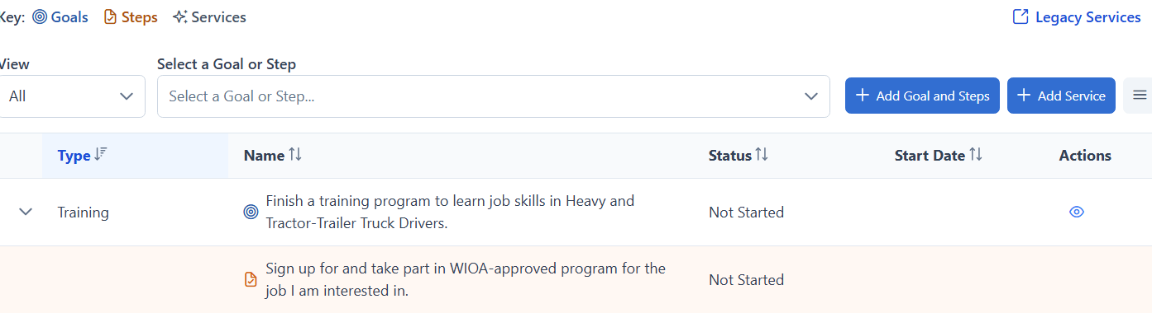

Step 3 — Open the Occupational Skills Training Service on the Career Plan
From the Career Plan select the "Add Service" button to create it, then select "Occupational Skills Training" (Adult, Dislocated Worker or Youth, depending on the customer’s program)
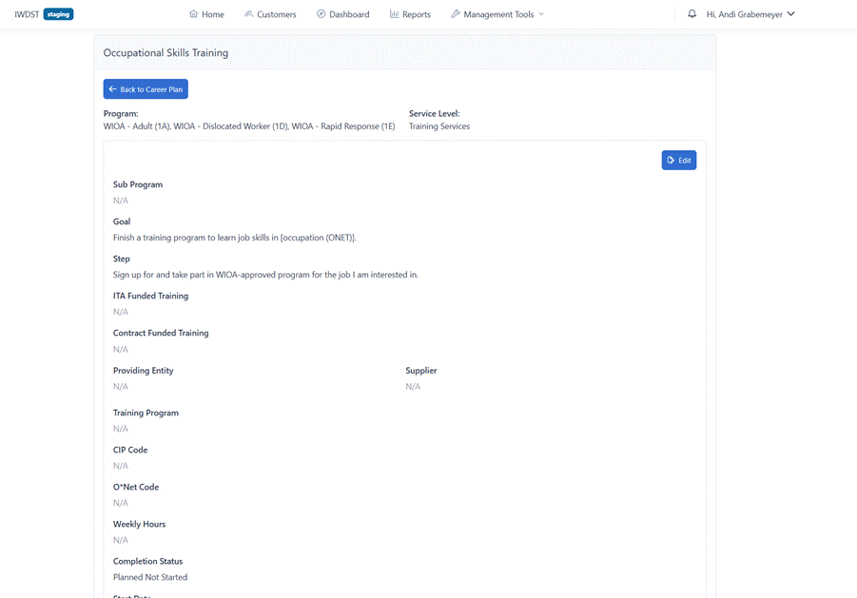

Click the Edit button to update the Episode Form
- Set ITA Funded Training to Yes: by setting the ITA Funded Training question to yes this will indicate the training will be paid for with an ITA voucher.
- Contract Funded Training: should be No for an ITA-funded service.
- Complete the Providing Entity (equivalent to the Training Provider of customer’s choice)
- Supplier information: will automatically populate with the training providers’ name again
  - Info Bubble: Because the provider is approved in LWIA 7, the ITA Review Status fields should now appear with three options: Ready for Review, ITA Approved, and ITA Denied.
- Set the ITA Review Status to "Ready for Review" and save the service. This single action replaces the legacy "Initial ITA Request" service entry.
- Select the appropriate Training Program from the drop list
- CIP and O*Net Codes will be prepopulated from information previously entered
- Weekly Hours-You can find the weekly hours on the program’s ETPL description page
- Completion Status-Planned Not Started
- Start/End Dates: Won’t be editable at this point (because you are entering the Initial ITA Request at this point)
- Case Notes: Enter a detailed case note related to the customer’s training and why they are recommended for training.
- Save the service- This single action replaces the legacy "Initial ITA Request" service entry — nothing else needs to be created or separately completed.
- If email not received from ISTS, please visit here to move forward with voucher process:

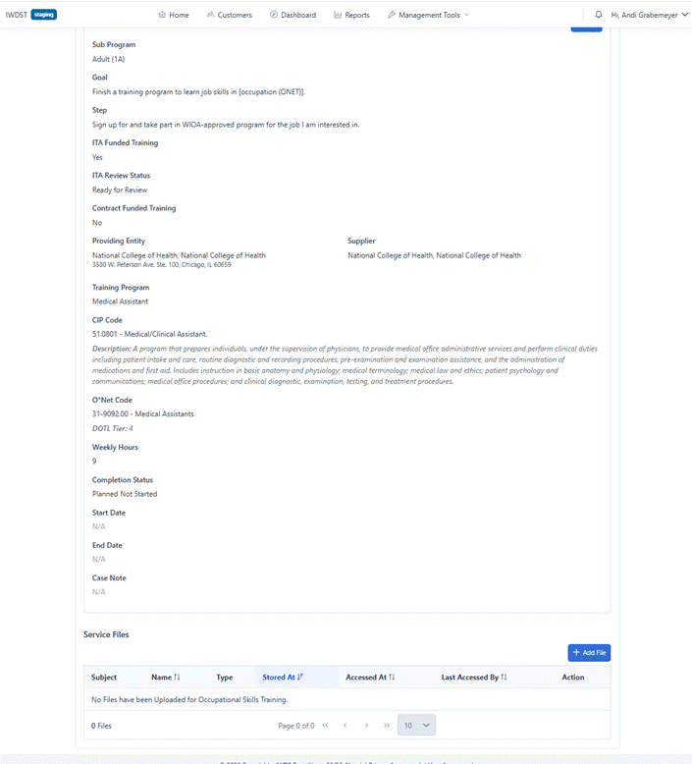

Step 4 — Nightly export to ISTS
Overnight, IWDS 2.0 exports any training service meeting all the following to ISTS:
- Provider is approved in LWIA 7
- ITA Funded Training = Yes
- ITA Review Status = Ready for Review
- Completion status = Not Started
Cutoff. The cutoff is 5:45 p.m. Central: Requests entered after that time—or over the weekend—do not transfer until the next business day. Confirm the current cutoff with your Program Relationship Manager if timing is critical.

Step 5 — Await the ISTS determination
The workflow with ISTS is unchanged. ISTS reviews the request and communicates approval or denial to the career planner directly by email within 5 days.
- If approved: ISTS will provide the career coach with a link to retrieve the customer’s voucher.
- Go back to the customer’s career plan
- Find the Occupational Skills Training Service and click on the eyeball to view and edit the service. Shown below
- 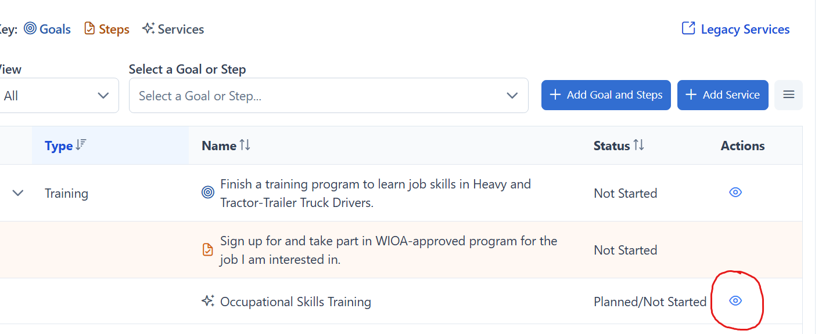
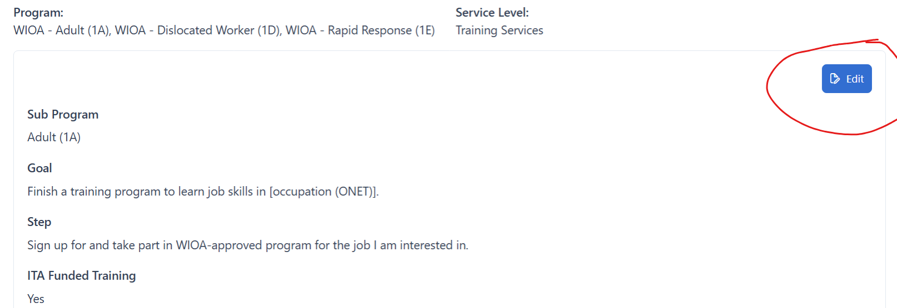

- Set the ITA Review Status to "ITA Approved." The training service is now unlocked and can move to In Progress.
If denied:
- Set the ITA Review Status to "ITA Denied." The service stays locked and cannot move to In Progress or Completed. Close the service.
- Update the Completion Status to Open
Note: ITA Denied status also applies to customers that have withdrawn from training.

Complete or close the service
- Once approved and training is underway, manage the service like any training enrollment: set it to In Progress when training begins, and to Completed (or another closure code) when training ends, entering the Last Activity Date and appropriate Completion Code.

ITA Review Status — Reference Key
ITA Approved and ITA Denied are mutually exclusive.
Status | Meaning | System Behavior
Ready for Review | The Career Planner has initiated the ITA request. | Service remains "Not Started." Included in that night’s export to ISTS.
ITA Approved | ISTS has approved the ITA voucher. Career planner updates manually after confirming with ISTS. | Service is unlocked and may move to "In Progress" once training begins.
ITA Denied | ISTS has denied the request or customer has withdrawn from training. Career planner updates manually after confirming with ISTS. | Service remains locked. Career planner must request to void the service.

Troubleshooting
If a request does not appear to reach ISTS as expected on the next business day, check the following on the training service:
- ITA Funded Training is set to Yes and the provider is correctly associated with LWIA 7.
- ITA Review Status is set to Ready for Review (not left blank).
- The customer is assigned to a career planner/case manager.
- Only one Occupational Skills Training service is entered.

If issue persists after correcting the above, please email your assigned Program Relationship Manager with the participant’s name and IWDS 2.0 ID.

