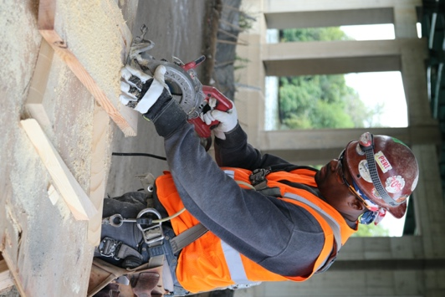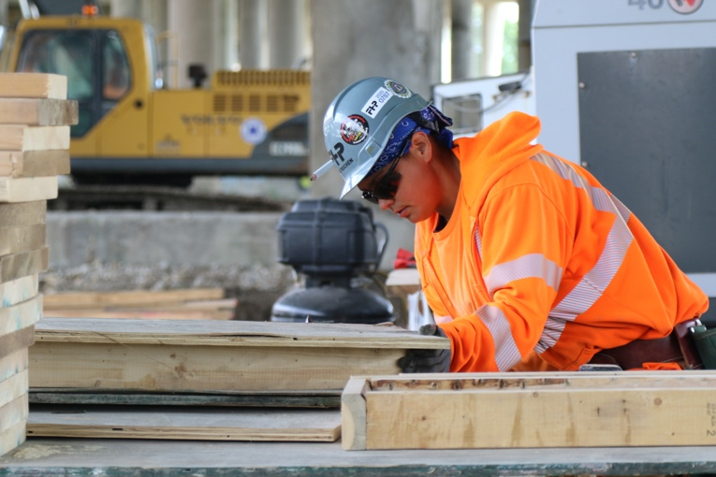

|  |  |  |
| --- | --- | --- |
| **2:30 a.m.** | Short description of content covered. Ideally twenty-five words or less. Include all major takeaways like what information will be critical for their involvement in the program | **Speaker 1**  **Title and Organization** |
| **8:45 a.m.** | Short description of content covered. Ideally twenty-five words or less. Include all major takeaways like what information will be critical for their involvement in the program | **Speaker 2**  **Title and Organization** |
| **9:00 a.m.** | Short description of content covered. Ideally twenty-five words or less. Include all major takeaways like what information will be critical for their involvement in the program | **Speaker 3**  **Title and Organization** |
| **10:00 a.m.** | Short description of content covered. Ideally twenty-five words or less. Include all major takeaways like what information will be critical for their involvement in the program | **Speaker 4**  **Title and Organization** |
| **11:45 a.m.** | Short description of content covered. Ideally twenty-five words or less. Include all major takeaways like what information will be critical for their involvement in the program | **Speaker 5**  **Title and Organization** |

**Illinois Tollway ConstructionWorks Open House  
December 20, 2021 l 2:00 p.m.**

Logo here

**Sub-Provider Name**

[JaneDoe@Provider.com](mailto:JaneDoe@Provider.com) l (312) 888-888 l ProviderName.com

**AGENDA**